Data-block 2nd practical: Run from scratch by deleting the terraform.tfstate terraform.tfstate.backup

>> 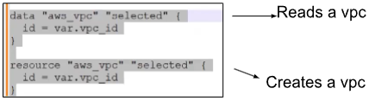

>> Amazon publishes its own AMI at regular intervals. These AMI are pulled by terraform.

* Terraform apply –auto-approve ……1st practical result

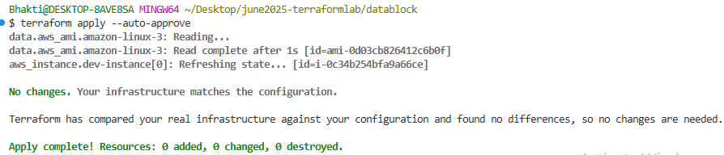

* Terraform destroy –auto-approve ……destroy all resources

Summary of issues completed and upcoming:

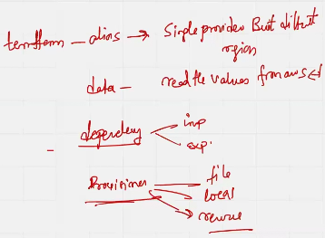

Dependency in Terraform

<https://developer.hashicorp.com/terraform/tutorials/configuration-language/dependencies> 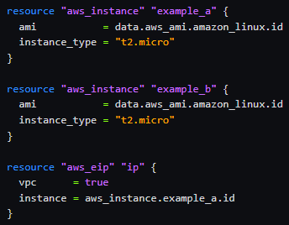 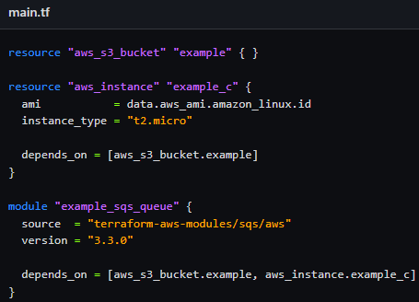

1 Implicit dependency 2 Explicit dependency

Provisioner in Terraform

<https://developer.hashicorp.com/terraform/language/resources/provisioners/syntax>

Steps to work with Dependency and Provisioner

<https://developer.hashicorp.com/terraform/language/resources/provisioners/syntax>

Goto VSCode >> Create folder >> explicit-dep, implicit-dep, provisioner-local, provisioner-remote.